California Institute of the Arts
Loops That Listen: A Voice-Controlled Dynamic Drum Looper with AI Variation

A thesis submitted in partial satisfaction
of the requirements for the degree Master of Fine Arts
in Music Technology
by
Paolo Sandejas
2026
Readers:
1st Reader: ___________________________
2nd Reader: ___________________________

Table of Contents
List of Figures iii
Abstract iv
Introduction 1
Chapter 1: Related Work
1.1 Intelligent Loopers
1.2 AI Drum Variation
1.3 Beatbox as Input
Chapter 2: System Design
2.1 Personalized Training
2.2 Real-Time Transcription
2.3 Spice Detection
2.4 AI Variation Bank
2.5 Weighted Variation Selection
2.6 Live Performance Controls
Chapter 3: Evaluation
3.1 Variation Coherence
3.2 Performer Observations
Conclusion
Works Cited

List of Figures
Figure 1. CHULOOPA system architecture. Three concurrent processes communicate via OSC.
Figure 2. Drum grid comparison showing the original recorded pattern alongside AI-generated variations at low (Var 1), medium (Var 3), and high (Var 5) spice levels.
Figure 3. CHULOOPA performance UI showing spice-driven shape colour feedback.
Figure 4. Hit-probability heatmaps for a simple kick-snare input aggregated over N=10 independent banks. Top: Var 1 (Low Spice). Bottom: Var 5 (High Spice).

Abstract
Looping systems are inherently repetitive—the same pattern cycles indefinitely, limiting the musical dynamics of a live performance. CHULOOPA is a dynamic drum looper that uses beatboxed input to create patterns, then autonomously varies them based on the performer's live musical energy, or 'spice'—a dBFS-mapped RMS measure of the live audio environment. At loop boundaries, one of five pre-generated variations from a grid-based decoder-only transformer is selected to match the current spice level. These five variants are generated in parallel at varying temperatures, then sorted by deviation score to maintain a reliable creativity spectrum. Variations range from subtle to adventurous (spice 0.2–1.0). CHULOOPA demonstrates that inherent repetition need not be a constraint: with AI mediation, the loop becomes dynamically expressive without losing its musical identity or ceding creative control to the machine.

Introduction
The strength of a loop is also its main constraint: once recorded, it never changes. For drum loops in live performance, this constraint is especially pronounced. Where a live drummer would subtly add fills, vary dynamics, or shift the groove to match the moment, a drum loop plays back identically every cycle. While not always undesired—static loops provide rhythmic stability and free the performer's attention—over time, an unchanging loop can feel lifeless, lacking the organic variation that makes live drumming compelling. How do we bring dynamic musicality to drum loops without sacrificing their stability?
CHULOOPA (ChucK-based Loop Operator for Performance Audio) is a voice-controlled dynamic drum looper that addresses this. Unlike prior intelligent loopers that require guitar, MIDI files, or grid-based GUIs, CHULOOPA uses voice input as its sole creation interface: a performer beatboxes a drum pattern, the system transcribes it in real-time via a user-trained KNN classifier, loops it, and immediately generates a bank of five AI variations at different creative levels. Simultaneously, the variant controller reads the live audio energy—spice—and at each loop boundary performs a weighted probabilistic selection from the variation bank to match the current musical moment, without manual intervention. The loop listens.

Chapter 1: Related Work
1.1 Intelligent Loopers
The Reflexive Looper (Marchini et al., 2017) established the paradigm of intelligent looping agents that adapt to a musician in real-time, using constrained optimization to select musical material at each beat. Shepardson (2023) extended this with the Living Looper: rather than replaying recorded audio, each loop channel uses a pre-trained RAVE autoencoder to project the recording into a latent space, where a lightweight linear model is fit per-recording, allowing the loop to drift and transform over time. Neither system offers a pre-generated variation bank spanning a controllable creativity spectrum, nor automatically selects from it based on live audio energy intensity. Rolypoly~ (Burloiu et al., 2020) takes a complementary approach, using RNNs pretrained on the Groove MIDI Dataset to adapt the microtiming and velocity of a loaded drum score to the human musician's timing. Rolypoly~ modulates how a pattern is played; CHULOOPA varies what is played.
1.2 AI Drum Variation
Bruford et al. (2020) present jaki, which generates 1-bar LSTM continuations of a seed drum pattern and tunes them to user-defined musical features via deep reinforcement learning. Alain et al. (2020) use active learning to converge on user drum-loop preferences from like/dislike ratings. Both are composition tools: offline, requiring explicit user feedback, not designed for live performance. CHULOOPA adapts feature-driven variation to a live looper context, replacing manual user feedback with automatic audio-energy-driven selection.
1.3 Beatbox as Input
Delgado et al. (2019) showed that vocal percussion styles vary significantly across amateur performers, motivating personalized, user-specific training. Stowell and Plumbley (2010) demonstrated real-time beatbox classification under latency constraints. Martanto et al. (2025) confirm KNN with MFCC features achieves strong accuracy for voice-derived percussion. Weber (2024) demonstrated real-time drum transcription with minimal training data.

Chapter 2: System Design
CHULOOPA runs as three concurrent processes (Figure 1): the main looper handles beatbox recording, drum classification, loop playback, and variation selection; the variant generator generates a bank of five AI variations in the background the moment a new pattern is recorded; and the variant controller continuously monitors the live audio environment, streaming a single energy value—spice—every 500 ms.
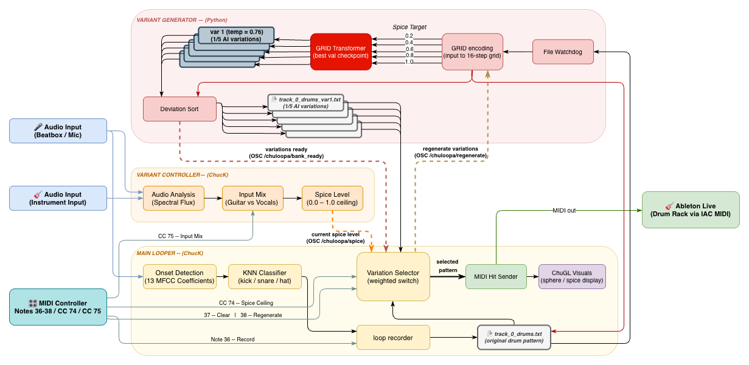
Figure 1. CHULOOPA system architecture. Three concurrent processes communicate via OSC: main looper, variant generator, and variant controller.
2.1 Personalized Training
Rather than training on a large generic beatboxing dataset, CHULOOPA fits a classifier to each individual user: 10 samples each of a kick, snare, and hi-hat, recorded in under five minutes via a training script. The system extracts 13 MFCC coefficients per onset—validated by Martanto et al. (2025) as outperforming spectral band energies for voice-derived percussion. A KNN classifier (k=3) trains automatically at startup in under one second. KNN was chosen deliberately: it performs well with as few as 30 samples, trains instantly, and requires no hyperparameter tuning.
2.2 Real-Time Transcription
Immediate audio feedback during recording is central to CHULOOPA's performance model: the performer hears classified drum samples in real-time while beatboxing, allowing technique correction before committing a pattern to loop. Onset detection uses spectral flux with adaptive thresholding (1.5x running mean) in 512-sample frames with 128-sample hop. Each onset is classified via MFCC-13 KNN, the corresponding drum sample plays immediately, and a MIDI note-on is sent to Ableton Live via the macOS IAC driver. Total input-to-playback latency is approximately 25 ms. The timestamped sequence is quantized to a 16-step grid and passed to the GRID Transformer, ensuring the original and all variations share the same temporal reference.
2.3 Spice Detection
Rather than asking the performer to manually set a creativity level, CHULOOPA reads the room. The variant controller continuously measures the energy of the live performance environment and maps it to a normalized spice value (0.0–1.0) that drives variation selection without intervention. The detector averages RMS energy over a 500 ms window and converts to dBFS: spice = clamp((dBFS - F) / (P - F), 0.0, 1.0), where F = -75 dBFS (noise floor) and P = -50 dBFS (expected peak). Spice is streamed to the main looper process via OSC every 500 ms.
2.4 AI Variation Bank
CHULOOPA's generation engine is a GRID Transformer: a 6-layer decoder-only model with 256-dimensional embeddings, 8 attention heads, feed-forward dimension 1024, 42-token vocabulary, and 4.8 million parameters, trained on 12,085 bar pairs from the Expanded Groove MIDI Dataset (Callender et al., 2020). When a loop is recorded, five parallel generation threads launch—one per spice target (0.2, 0.4, 0.6, 0.8, 1.0)—with sampling temperatures increasing with spice target (T = 0.6 + 0.8 x spice). Variants are sorted ascending by deviation from the original so slot 1 is always most conservative and slot 5 most adventurous. Total generation time: 3–5 seconds on consumer CPU hardware (Figure 2).
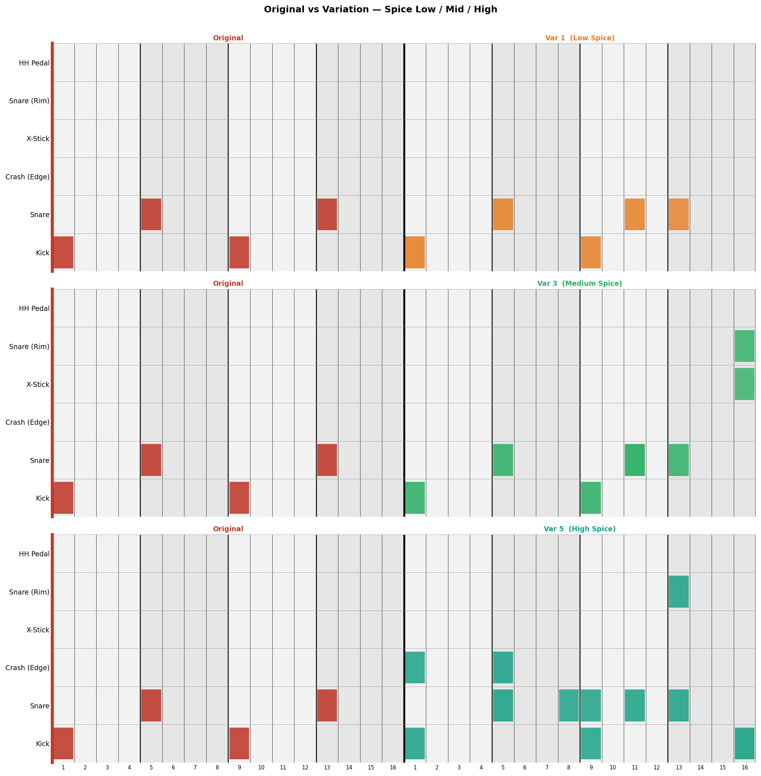
Figure 2. Drum grid comparison showing the original recorded pattern alongside AI-generated variations at low (Var 1), medium (Var 3), and high (Var 5) spice levels. Higher spice produces denser fills and introduces new drum voices.
2.5 Weighted Variation Selection
At each loop boundary, the main looper draws from a probability distribution whose shape slides up the variation bank as spice increases (Table 1). The distribution includes the original pattern as a valid option. Selection operates on a rolling 4-bar spice average—the first four loops serve as a calibration window—and a repeat-prevention rule caps consecutive plays of the same variant at two. CC 74 sets a spice ceiling, a hard cap on how adventurous the system can become.
Table 1. Selection weights per spice tier.
Spice | Orig. | V1 | V2 | V3 | V4 | V5
0.00 | 0.50 | 0.40 | 0.10 | 0.00 | 0.00 | 0.00
0.25 | 0.20 | 0.40 | 0.30 | 0.10 | 0.00 | 0.00
0.50 | 0.05 | 0.20 | 0.40 | 0.30 | 0.05 | 0.00
0.75 | 0.00 | 0.10 | 0.30 | 0.40 | 0.20 | 0.00
1.00 | 0.00 | 0.00 | 0.20 | 0.40 | 0.30 | 0.10

2.6 Live Performance Controls
Inspired by hardware loopers, variation loading queues during the current cycle and executes at the next loop boundary, preventing mid-pattern interruptions. MIDI controls: Note 36 (hold) to record loop; Note 37 to clear; Note 38 to regenerate the full variation bank; CC 74 to set the spice ceiling; CC 75 to adjust instrument/vocal input mix. ChuGL visual feedback (Figure 3) closes the loop for the performer: the central shape shifts colour with spice level (blue to yellow) and pulses on each hit.
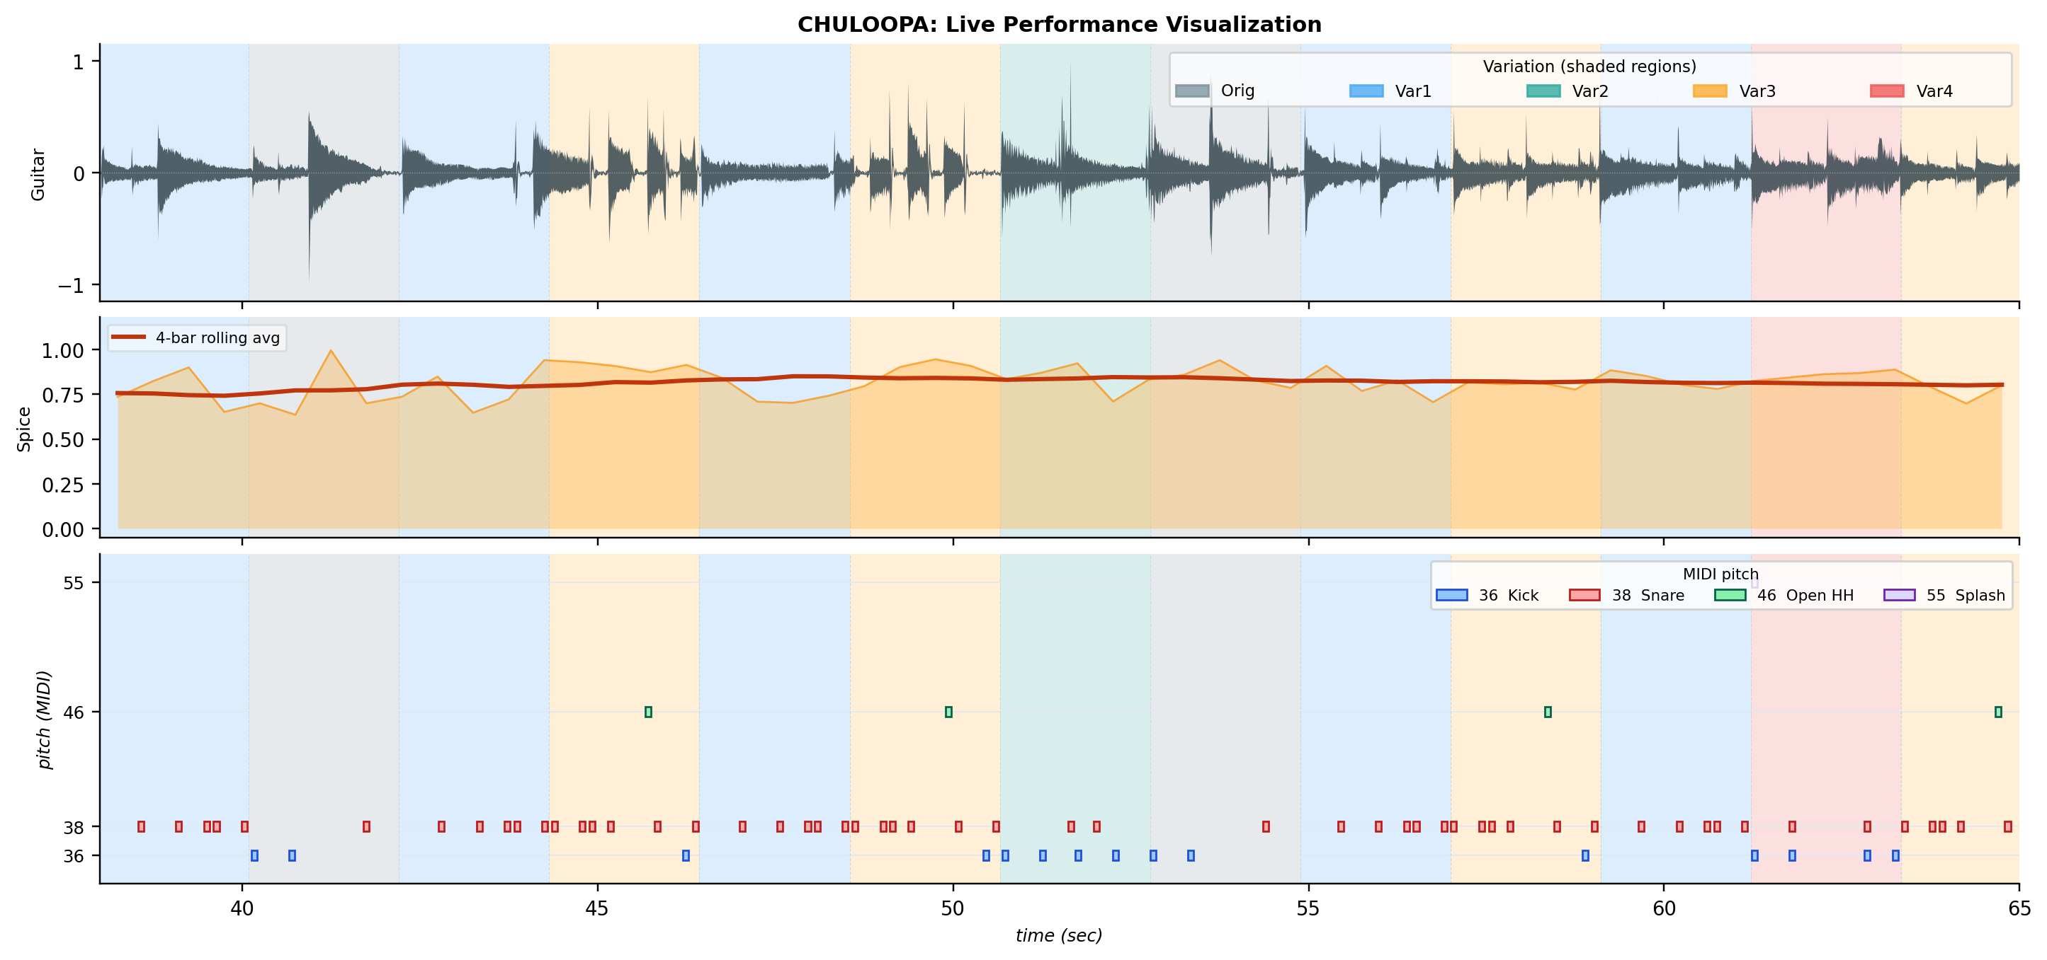
Figure 3. CHULOOPA performance UI. Shape colour tracks spice level (blue = low, yellow = high); spice slider shows the rolling average currently driving variation selection.

Chapter 3: Evaluation
The central evaluation question is whether CHULOOPA's AI-generated variations remain musically coherent with the performer's input while offering a reliable, controllable range of complexity.
3.1 Variation Coherence
We ran N=10 independent generation banks on a simple kick–snare pattern (two kicks and two snares across a 2.6-second loop). Each bank generates five variants at spice levels 0.2–1.0, deviation-sorted so slot 1 is always the sparsest and slot 5 the most adventurous. Hit-probability heatmaps (Figure 4) aggregate binary grids across all 10 runs; darker cells indicate more consistent activation.
Var 1 produces an average of 5.4 hits/bar, with input positions attracting 82.5% consistent activation. Var 5 reaches 12.7 hits/bar: snare rows spread broadly, kick maintains its step-1 anchor, and hi-hat and tom voices emerge. New-cell probability stays below 3.2% across all spice levels. The density gradient (5.4 to 12.7) confirms the spice axis produces a reliable complexity spectrum, with input positions serving as structural anchors throughout.
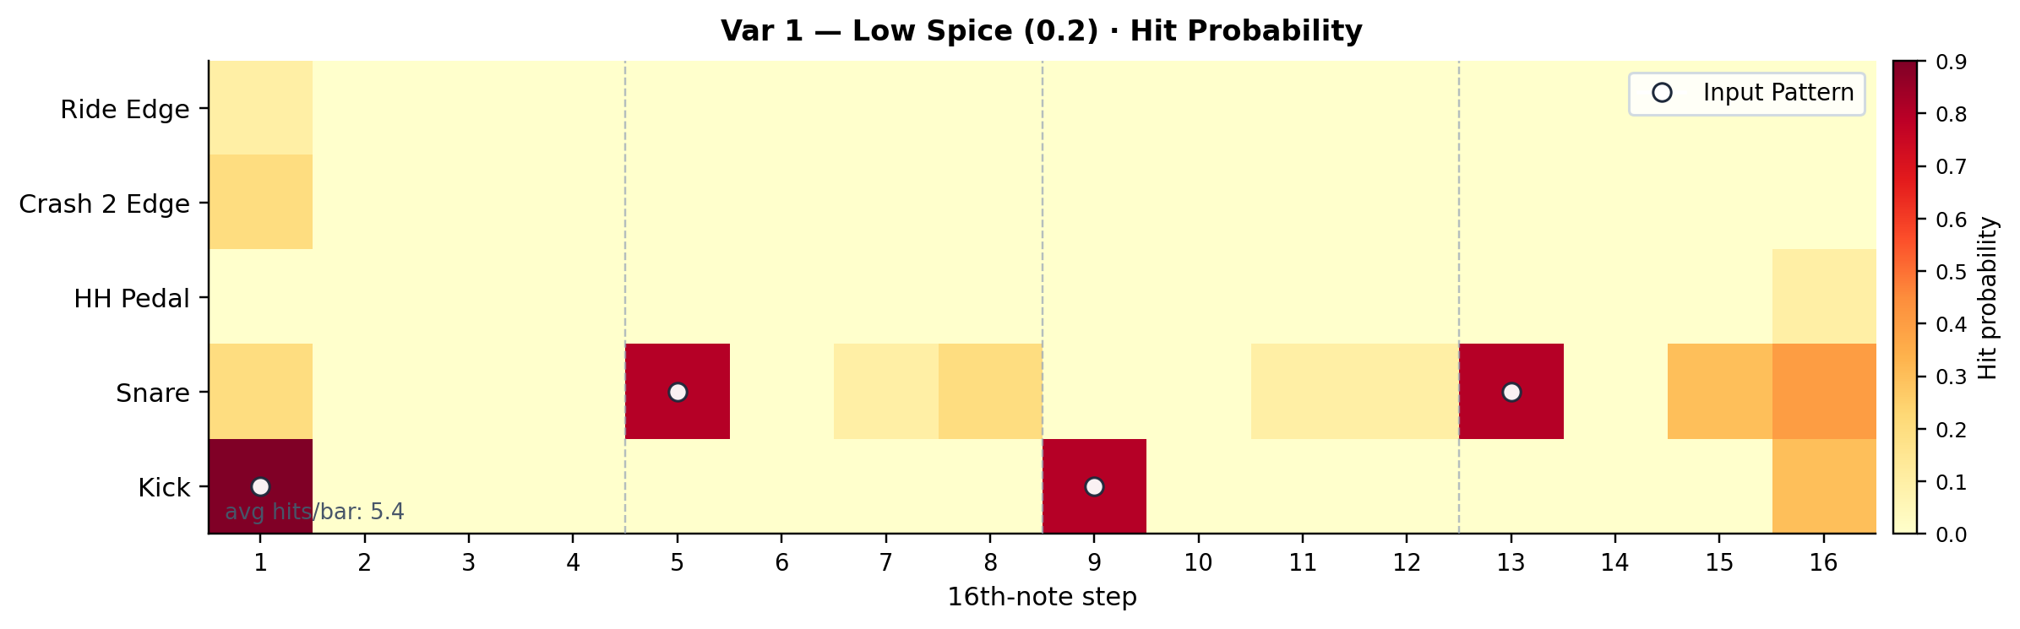
Figure 4 (top). Var 1 (Low Spice, 0.2) — sparse additions, input positions dominant. Aggregated over N=10 independent banks; white circles mark input pattern positions.
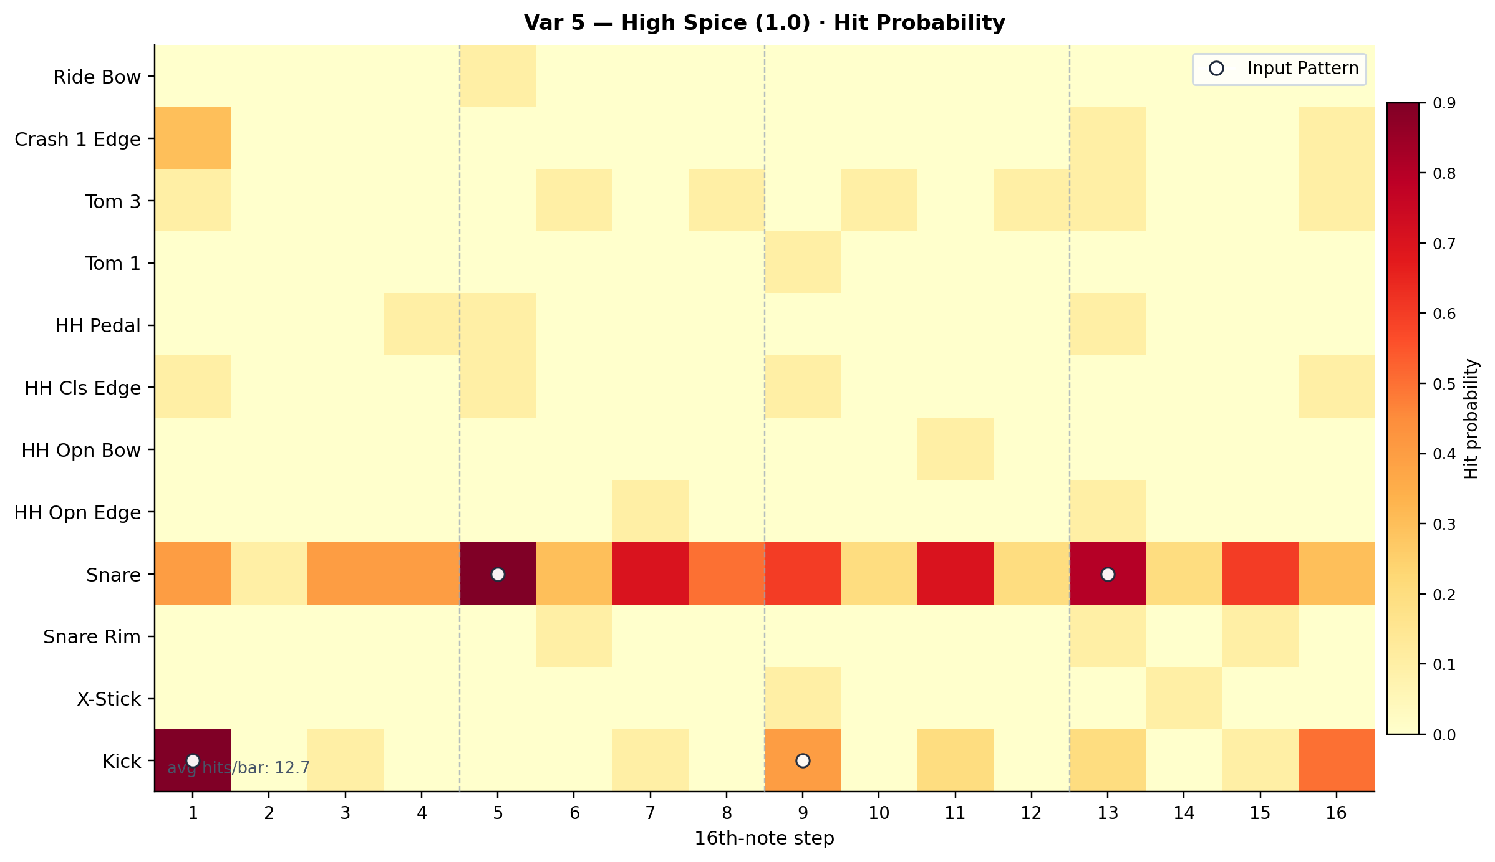
Figure 4 (bottom). Var 5 (High Spice, 1.0) — elaborated groove with hi-hats, toms, and snare fills; input anchors remain visible at steps 1 and 9.
3.2 Performer Observations
The author performed with CHULOOPA across multiple sessions. All generated variations were assessed as coherent musical ideas; the only failure cases were input-side quantization artifacts—occasionally a hit shifted by one step—rather than output-side incoherence. Mid-range spice values (approximately 0.4–0.6) proved most musically satisfying. Hearing the system return to the original pattern at low spice served as a rhythmic anchor. Unlike static loops, CHULOOPA invites attention when given the spotlight, with the performer remaining compositionally in control.

Conclusion
CHULOOPA demonstrates that an AI looper can serve as a disciplined co-performer rather than a co-composer: it elaborates the performer's groove without displacing it.
Current limitations reflect deliberate design constraints. The 16-step quantization grid ensures reliable beat alignment but excludes swing, non-4/4 meters, and 32nd-note micro-timing. Variations are conditioned to continue from the input rather than replicate it: they are always coherent with it, but may reinterpret it.
Future work will extend CHULOOPA toward multi-track looping, broader rhythmic vocabularies (swing, compound meters), and melodic generation, building toward a complete AI performance partner that adapts across a full live set. The loop listens. The performer leads.

Works Cited
Alain, G., Engel, J., Hawthorne, C., & Simon, I. (2020). DeepDrummer: Generating drum loops using deep learning and a human in the loop. ICML Workshop.
Bello, J. P., Daudet, L., Abdallah, S., Duxbury, C., Davies, M., & Sandler, M. B. (2005). A tutorial on onset detection in music signals. IEEE Transactions on Speech and Audio Processing, 13(5), 1035–1047.
Bruford, F., Bhattacharya, A., & Weyde, T. (2020). jaki: An adaptive drum machine for live performance. NIME.
Burloiu, G., Farca, R., & Cosma, M. (2020). Rolypoly~: Learned expressive drum accompaniment. NIME.
Callender, L., Hawthorne, C., & Engel, J. (2020). Improving perceptual quality of drum transcription with the Expanded Groove MIDI Dataset. arXiv:2004.00188.
Delgado, A., Laney, R., & Saitis, C. (2019). A dataset for beat-tracking of vocal percussion sounds. SMC.
Gillick, J., Roberts, A., Engel, J., Eck, D., & Bamman, D. (2019). Learning to groove with inverse kinematics. ICML.
Lubart, T. (2005). How can computers be partners in the creative process. International Journal of Human-Computer Studies, 63(4–5), 365–369.
Marchini, M., Lepri, G., & Purwins, H. (2017). The Reflexive Looper for solo musical improvisation. CHI.
Martanto, R., et al. (2025). Beatbox classification using KNN and MFCC features. International Conference on Signal Processing.
Shepardson, V. (2023). The Living Looper: Audio loop transformation with neural synthesis. NIME.
Stowell, D., & Plumbley, M. D. (2010). Real-time, frame-by-frame, musical beatboxing recognition. DAFx.
Toussaint, G. T. (2004). A comparison of rhythmic similarity measures. ISMIR, 5, 242–245.
Wang, G., Salazar, S., & Cook, P. (2015). ChucK: A strongly timed computer music language. Computer Music Journal, 39(4), 10–29.
Weber, T. (2024). Real-time drum transcription with minimal training data. ICMC.

